ADVANCED – Creating Snippets

Creating Snippets

You’ll add the table to the snippets library
Click on Snippets library in the Code window
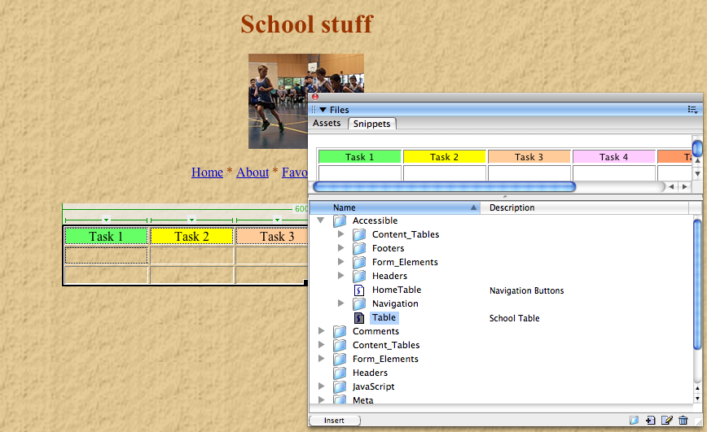

- With the table selected in place.
- In the Snippets panel, click the plus (+) button (New Snippet) a new untitled will appear in the Snippet window
- Title the snippet Table
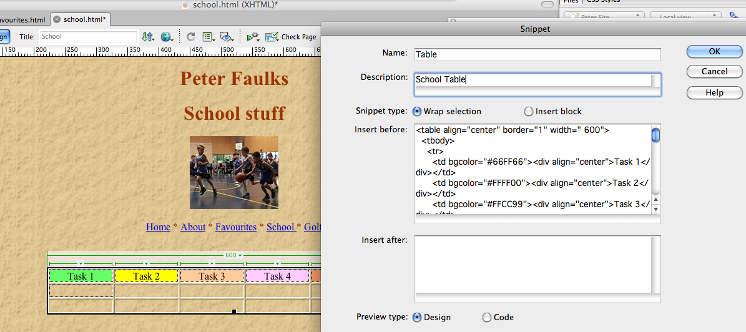
- Save your document (File > Save).
Open one of your files
I used Favourites.html
To use the snippet
Open Snippets
Click on Table it and drag Table onto Dreamweaver at the point where you want it to appear.
Or Click on INSERT
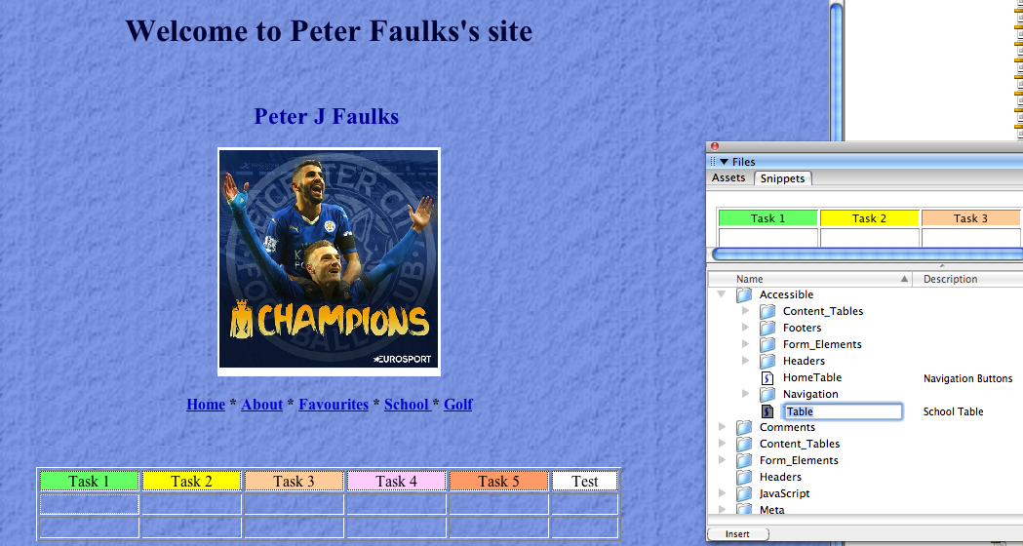
- Save your document (File > Save).
To use the snippet click on it and drag Toolbar1 onto Dreamweaver at the point where you want it to appear. Or Click on INSERT

- Open Fireworks create a document 200 pixels (7cm) x 200 pixels with a transparent background.
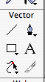

- Select the text tool, font and type your name in a font that fits the document.

- Centre this

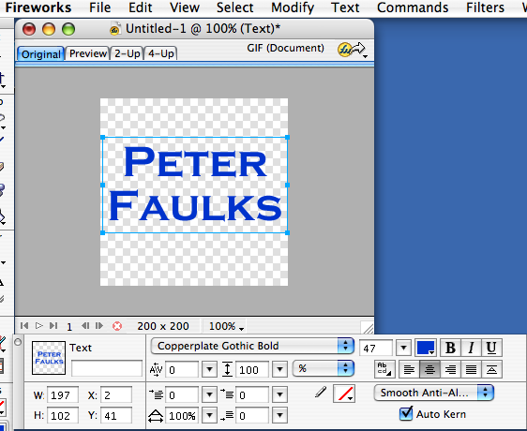
Font style
Font sizing slider
Centre

- Select the text box with the black arrow
- create an effect using the + button on the effects

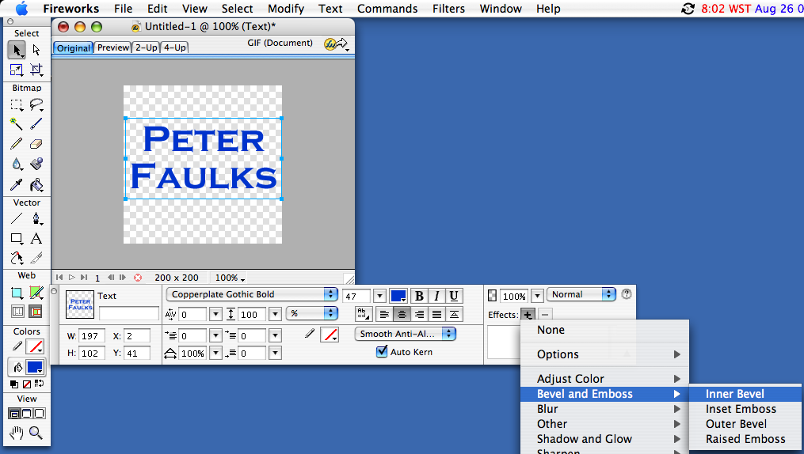

I choose Inner Bevel you can adjust the settings to suit
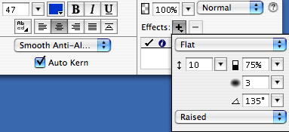

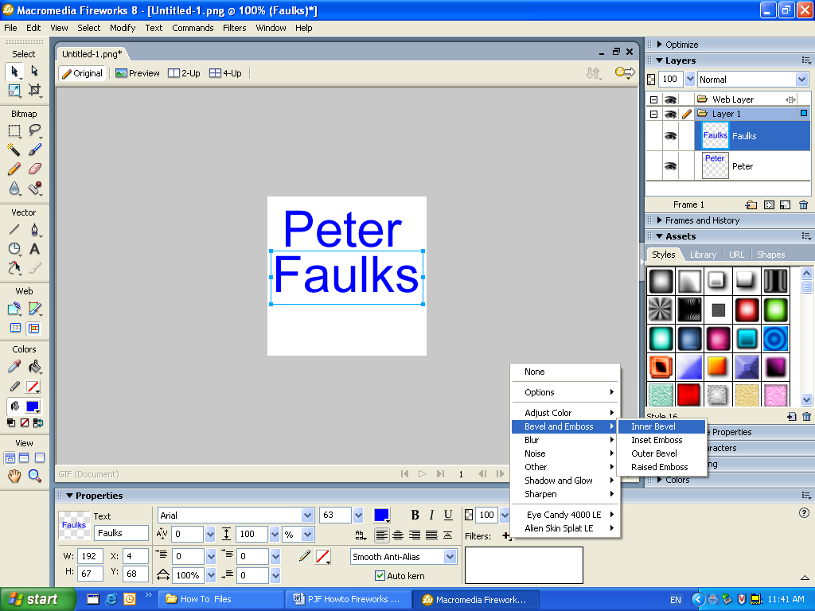
Windows environment Filters + and Bevel and Emboss

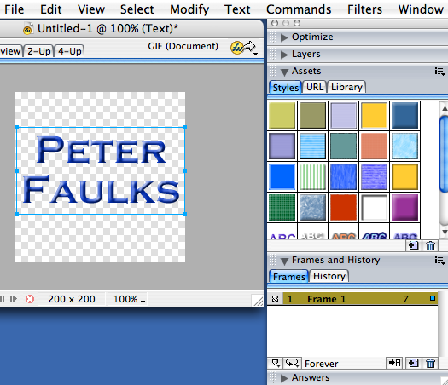
In the frames window you can see we have frame 1
Playing at 7 fps

With Frames

Add a duplicate frame
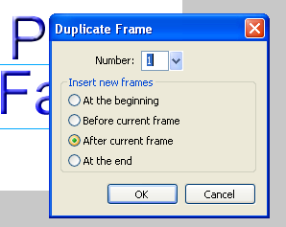
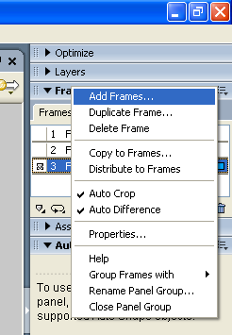

and place it after the current frame.

Save at least three duplicate frames
On the second duplicate frame remove the Filter effect click on the -
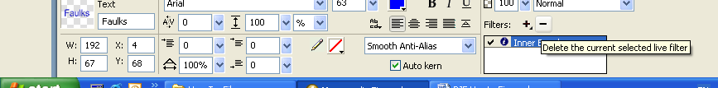
For each name remove one example of the effect

Hit play to see your animation and adjust to make the animation more exciting.

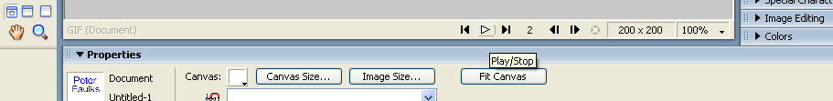

Save as animated Gif


Next few lessons we will add more animation and effects

